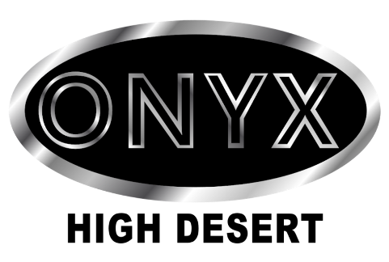
Onyx High Desert Member Application
Welcome to Onyx High Desert (OHD)! This is the membership application form for our organization.
Please note that membership in OHD is not open continuously because of a period pledge process. This form may be open continuously so that you may express interest; however, our intake of members occurs at specific times during the year.
One should not apply for membership unless you have attended OHD events and have one or more sponsors that are Full Brothers or Associates of OHD.
Please read the following information before filling out this application. Please only fill out the application if you have been vetted by our members and have attended our events.
Becoming a Member
Full Membership in ONYX is open to gay or bisexual man of color and participate in a structured pledge process lasting three to six months, depending on the time needed for the pledge class to bond, learn the required ONYX history and protocols, participate in activities, attend events, and contribute meaningfully to the chapter. Full Brothers receive voting rights and enjoy full privileges within the chapter.
​Associate Membership in ONYX is open to men and women of any race, identity, or orientation. Associates must complete an affiliation period by participating in a structured pledge process lasting three to six months, depending on the time needed for the pledge class to bond, learn the required ONYX history and protocols, participate in activities, attend events, and contribute meaningfully to the chapter.
​The membership team will host an interest gathering. This gathering allows you to meet current members and ask any questions about the organization or chapter. Before attending an interest meeting, we encourage you to join our events so you can get to know us, and we can get to know you.
New applicants must attach a clear photo (face picture) with their application.
​ Vetting Process
​A vetting process, overseen by the Membership Chair, will allow members to participate in interviews with prospective pledges. Participating members will report their findings to the Membership Chair, who will determine recommendations for the upcoming pledge class.
​Upon acceptance into the pledge class, you will receive your requirements, which include attending meetings, completing assignments, and actively participating in ONYX events throughout the pledge period.
Membership Levels​
Full Brother
- Open to gay or bisexual Men of Color living in OHD region (New Mexico) who intend to participate actively.
- Includes voting rights, eligibility for elective office, and the ability to serve as a representative at formal meetings.
- Applicants must not be a full member of any other Leather/Levi back-patch club.
- Leasing of ONYX colors is granted upon initiation.
- Initiation and annual fees are required.
- Photo and proof of age are required.
- Annual dues: $100
​Associate
- Open to all, regardless of race, color, gender, gender identity, or club affiliation.
- Does not have voting rights and may be asked to leave during certain discussions.
- Leasing of associate colors (small insignia) granted.
- Requires an in-person interview.
- Photo and proof of age required.
- Annual dues: $50
If you need more information, please visit our website at https://onyxhighdesert.com.
If you feel that you are qualified and ready to submit an application, please proceed below.
* Indicates required question

ONYX High Desert Membership Application
Please complete all required fields marked with an asterisk (*). Print clearly if completing by hand.

Personal Information
* Full Name: ________________________________________
* Street Address: ____________________________________
* City: ____________________ * State: __________ * Postal / Zip Code: __________
* Country: ________________________________
* Email Address: ____________________________________
* Phone: ___________________________________________
* Date of Birth (must be at least 21 years old): ____________________
* Ethnicity:
☐ American Indian/Indigenous or Alaska Native
☐ Asian or Pacific Islander
☐ Black or African American
☐ Hispanic or Latino
☐ Caucasian
☐ Prefer not to answer
☐ Other: ________________________________
Facebook Handle: ________________________________
Twitter Handle: __________________________________
Instagram Handle: ________________________________

Membership Details
* Membership Type:
☐ Full Brother
☐ Associate
* Sponsor(s) (must be active ONYX members): ________________________________________________

Background Questions
* Why do you wish to join ONYX High Desert?
______________________________________________________________________________
______________________________________________________________________________
______________________________________________________________________________
What is your understanding of ONYX High Desert?
______________________________________________________________________________
______________________________________________________________________________
______________________________________________________________________________
What ONYX events have you attended?
______________________________________________________________________________
______________________________________________________________________________
______________________________________________________________________________
* What are your expectations of ONYX High Desert?
______________________________________________________________________________
______________________________________________________________________________
______________________________________________________________________________
* What can you contribute to ONYX High Desert?
______________________________________________________________________________
______________________________________________________________________________
______________________________________________________________________________
* When you think of the words “Educate, Empower, and Explore,” how do you think they will shape your participation in ONYX?
______________________________________________________________________________
______________________________________________________________________________
______________________________________________________________________________

Commitments
* If called upon after acceptance as a Full or Associate Brother, are you willing, capable, and able to take on some form of leadership in the club?
☐ Yes ☐ No
* After acceptance as a Full or Associate Brother, are you willing to adhere to all rules of ONYX High Desert?
☐ Yes ☐ No
If no, please explain:
______________________________________________________________________________
______________________________________________________________________________

